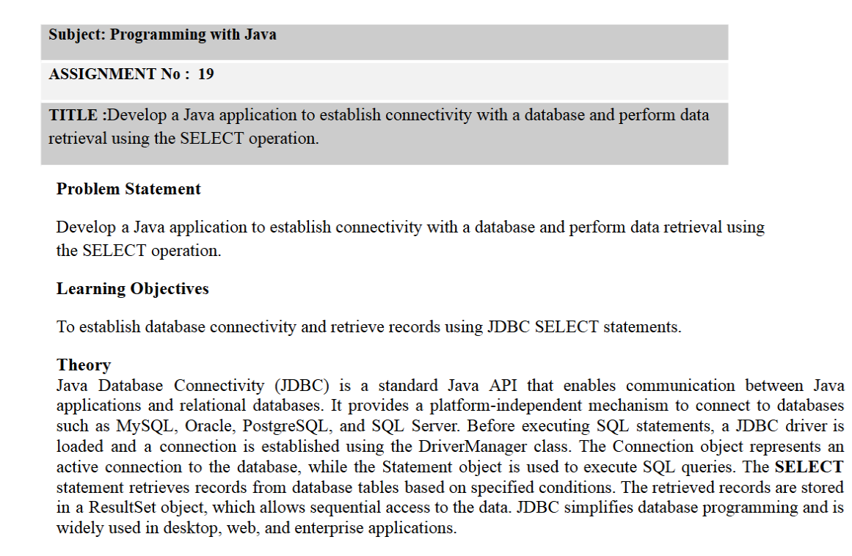
1. Theory
Java Database Connectivity (JDBC) is a Java API used to connect Java applications with databases such as MySQL. It allows programs to execute SQL queries and retrieve data from database tables.
The main JDBC components are:
- DriverManager: Establishes a connection between Java and the database.
- Connection: Represents the connection with the database.
- Statement: Executes SQL queries.
- ResultSet: Stores the records returned by a SELECT query.
- SELECT statement: Retrieves records from a database table.
JDBC allows Java applications to access and display database information efficiently. It is commonly used in student management, employee management, banking, and other database-driven applications.
2. Algorithm
- Start the program.
- Import the required java.sql package.
- Load the MySQL JDBC driver.
- Establish a connection with the database using DriverManager.
- Create a Statement object.
- Execute the SELECT query using executeQuery().
- Store the retrieved records in a ResultSet object.
- Use the next() method to access each record.
- Retrieve and display the required fields from the database.
- Close the ResultSet, Statement, and Connection.
- Handle exceptions using a try-catch block.
- Stop the program.

- 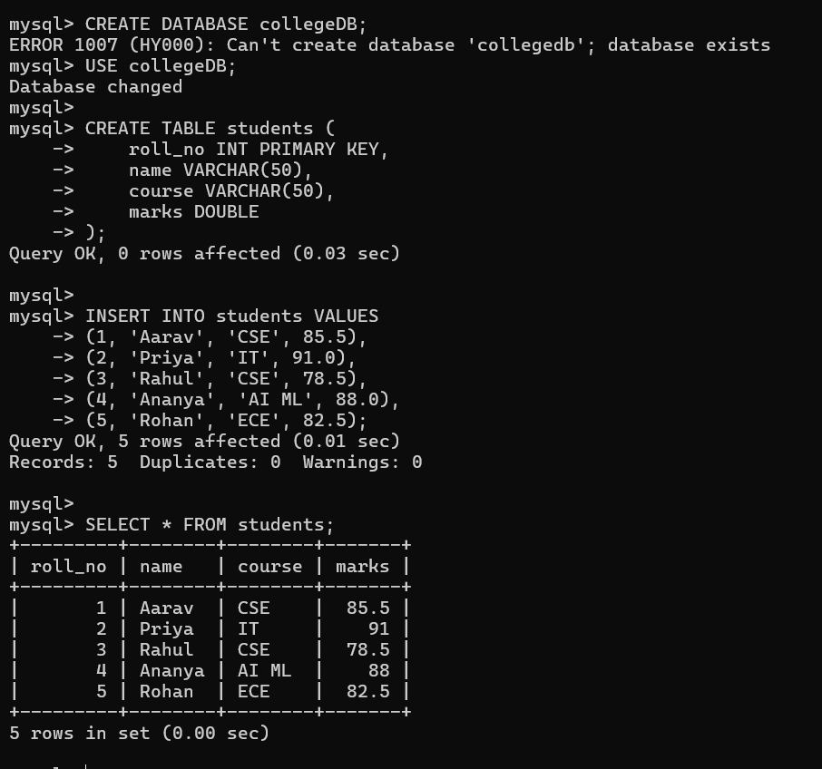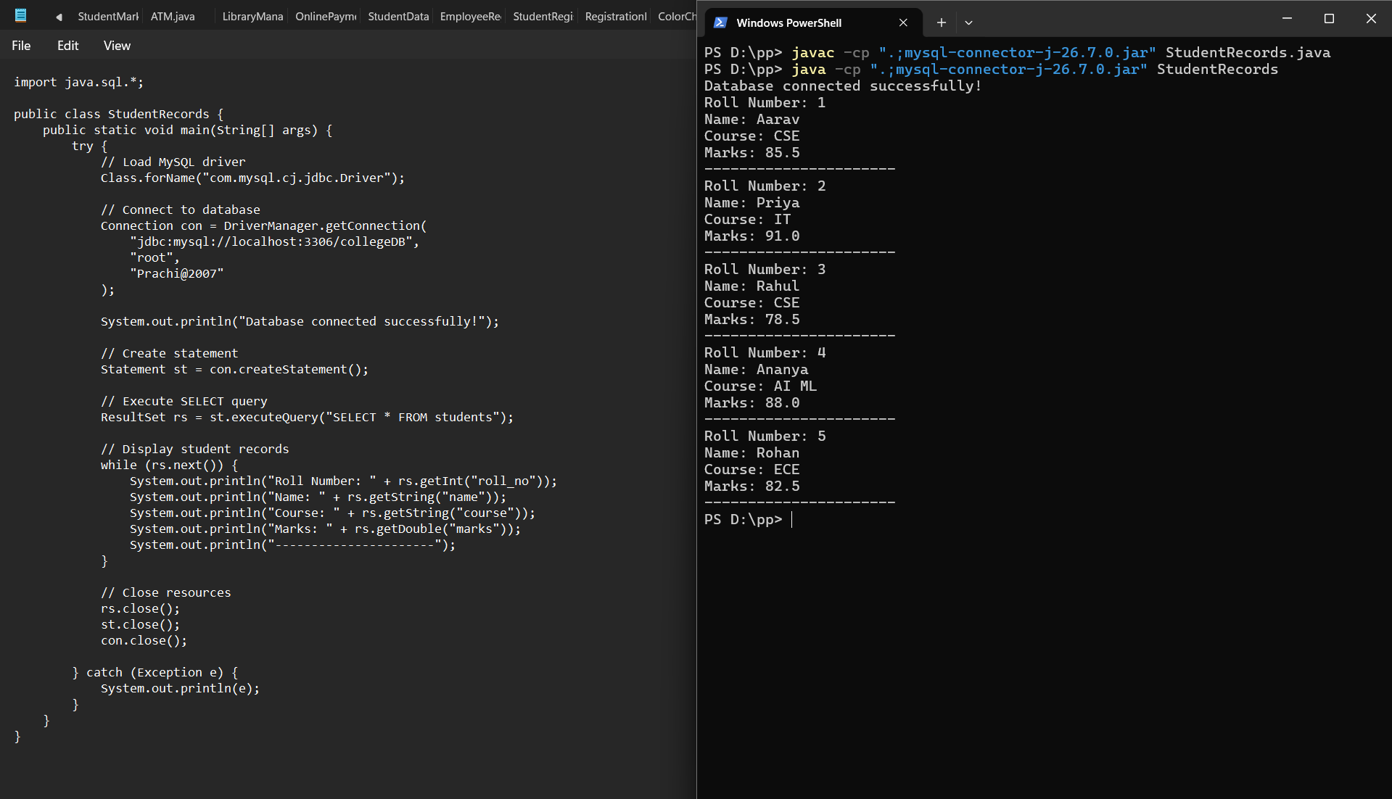

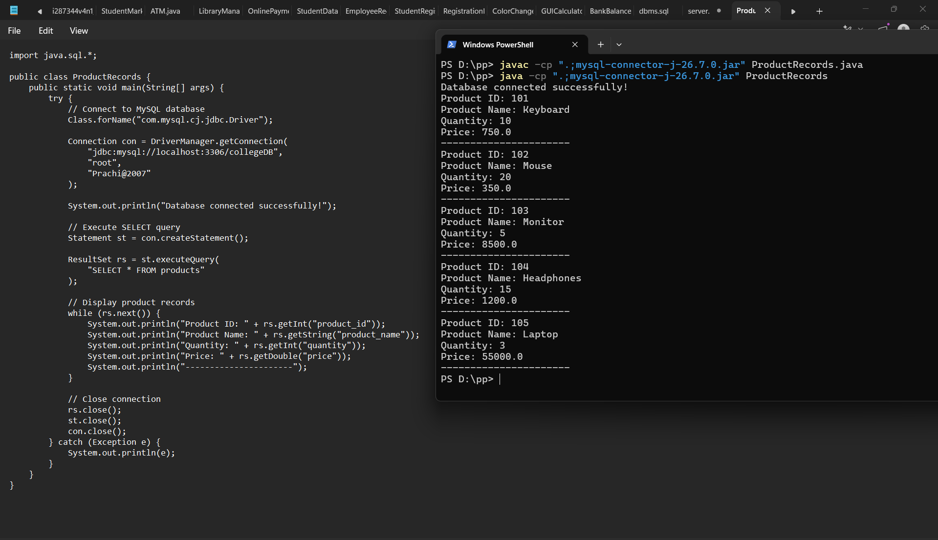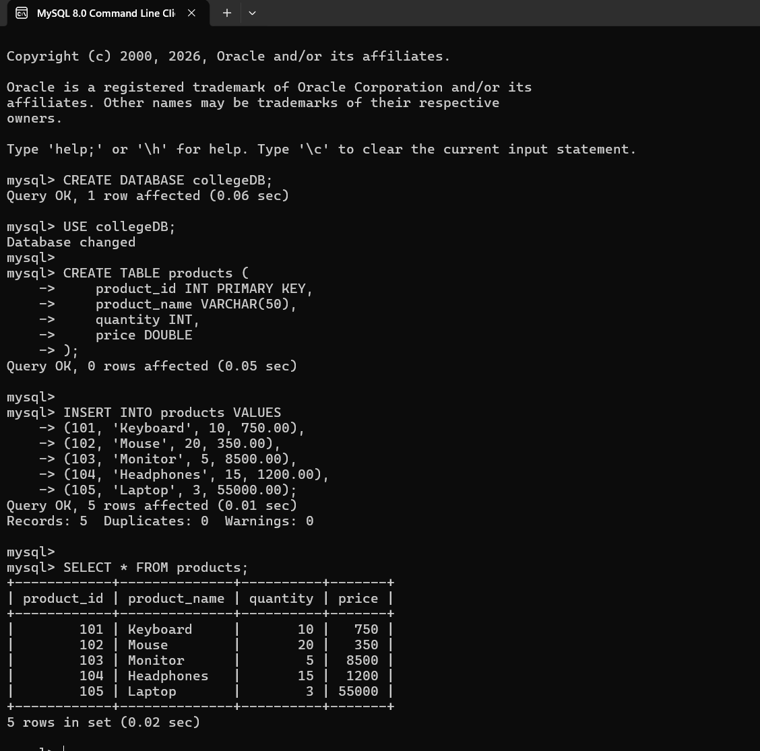
3. Conclusion
Thus, we successfully implemented database connectivity in Java using JDBC and retrieved records from a MySQL database using the SELECT statement. We learned how to use DriverManager, Connection, Statement, and ResultSet to establish a database connection, execute SQL queries, and display the retrieved information. Hence, this assignment helped us understand the basic process of accessing and retrieving data from a database using Java.

